Giulia Vanin

Excel and Tableau assignment

**Policies and Procedures**

When working with data, adherence to certain policies is crucial to ensure privacy, security, and ethical use. Here's an outline of key policies that need to be considered:

* **Data Privacy Policy:**

Define how personal and sensitive data will be collected, stored, processed, and shared.

Specify procedures for obtaining consent from individuals for data collection and usage.

Ensure compliance with relevant data privacy regulations such as GDPR (General Data Protection Regulation) or CCPA (California Consumer Privacy Act).

* **Data Security Policy:**

Establish protocols for safeguarding data against unauthorized access, disclosure, alteration, or destruction.

Implement encryption techniques to protect data both in transit and at rest.

Define access controls and permissions to limit data access to authorized personnel only.

Conduct regular security audits and assessments to identify and address vulnerabilities.

* **Data Retention Policy:**

Determine the period for which data will be retained based on legal, regulatory, and business requirements.

Outline procedures for securely deleting or anonymizing data once it reaches the end of its retention period.

* **Data Quality Policy:**

Establish standards and procedures for ensuring the accuracy, completeness, and reliability of data.

Implement data validation processes to detect and correct errors or inconsistencies.

Define roles and responsibilities for data quality management across the organization.

* **Ethical Data Use Policy:**

Define principles for ethical collection, analysis, and usage of data.

Address issues such as bias, discrimination, and fairness in data-driven decision-making.

Ensure transparency and accountability in how data is used, particularly when it involves sensitive or potentially controversial topics.

* **Compliance Policy:**

Ensure compliance with relevant industry standards, regulations, and contractual obligations.

Stay updated on changes to data-related laws and regulations, and adapt policies accordingly.

Establish procedures for responding to data breaches or incidents in compliance with legal requirements.

* **Data Governance Policy:**

Define governance structures, roles, and responsibilities for managing data assets within the organization.

Establish processes for data stewardship, data classification, and metadata management.

Promote a culture of data stewardship and accountability across the organization.

* **Training and Awareness Policy:**

Provide training and awareness programs to educate employees about their roles and responsibilities regarding data management. Raise awareness about data privacy, security, and ethical considerations. Ensure that employees understand the importance of complying with data policies and procedures.

By adhering to these policies, organizations can effectively manage and leverage data assets while mitigating risks and ensuring compliance with legal and ethical standards.

GDP

1. Set a password to protect the workbook

Save as – Tools – General options – Password to Open -> **Assignment123**

2.Highlight column C and change the data to display in British Pound symbol

3.Turn the GDP sheet into a table.

4.Filter the table to display only the information for 2019

5.Next create a chart that will only display the following data ‘Rank, Country and GDP -per capita (PPP). The chart can be anything as long as it issuitable.

6. Using your creative skills edit the chart a. Add a title. Add X and Y axis labels. Make the chart visually pleasing

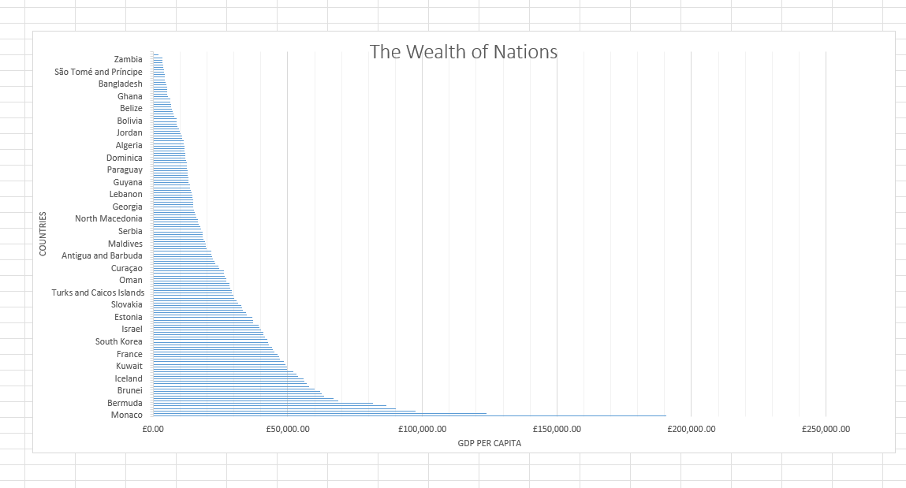



7.Move the chart to a new sheet tab and label with a suitable name

8.Create a sort for the top 20 highest ranking counties

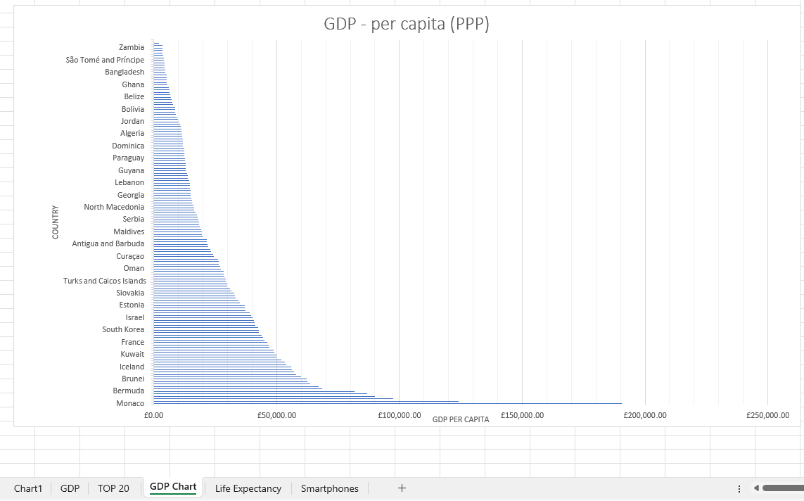



9. Next create a new Bar chart to display the 20 highest-ranking countries from your sort and then move the chart to be underneath the table

10. Colour the background by highlighting the area underneath the table Find the add a fill color icon and select a color.